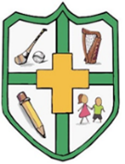

Court N.S. Monamolin
Ms O’Brien & Ms Murphy

Materials list: 1st class 2026-2027

Pencils, pencil sharpener, rubber
1 red pen
30cm ruler
1 A4 mesh zip folders (Class work)
1 B4 mesh zip folders (Slightly larger than A4 - Homework folder)
2 large glue sticks
Colouring Pencils/Crayons/Twistables
A3 art folder

Note:

Please ensure that your child has two pared pencils in their pencil case each morning.
Please clearly label your child’s belongings – school jumper, coat, lunch box, drinks bottle, pencil case, crayons.

