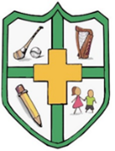

Court N.S. Monamolin
Ms Redmond

Materials list: Junior Infants 2026-2027

4 tubs of Playdoh (“Playdoh” brand – approx.. €5 for pack of 4)
Pencils, pencil parer, rubber
2 A4 mesh zip folders
2 large glue sticks
Crayons/”Twistables” crayons (no markers or colouring pencils)
A3 art folder
Art apron/old t-shirt (please label)

Note:

Please ensure that your child has two pared pencils in their pencil case each morning.
Please clearly label your child’s belongings – school jumper, coat, lunch box, drinks bottle, pencil case, crayons.

